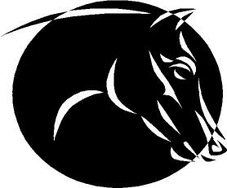
Great Lakes Congress, Inc.
www.GreatLakesCongress.com Founded 1984/Incorporated 2004
41 Years of Horses, Fun and Friendship!!

RESULTS of the GLC No Frills Show, December 6, 2025
Huntley Park District, Huntley, IL

Judges:
Breyer Emma Costello
China Marilou Mol
Resin/Custom Lara Heidkamp
Stone and Youth Sam Thompson
Performance/Youth Perf Tiffany Purdy

Entrants: Celeste Bergman CRBR, Steff Bodamer SLB; Dani Boiko DB; Emma Costello ECC; Liisa Erita LME; Gianna Fanelli GF; Erin French EEF; Ashley Getsay AG; Lara Heidkamp LMH; Kathy Hoffman KWH; Kerri Johnson KMJ; Kelsey Kramer KEK; Erin Krei EJK; Marilou Mol MCM; Jenna Murphy JMM; Mikayla Murphy MMM; Madisyn Murphy MGM; Mary Jo Nerly MJN; Susan Newcomb SMN; Emma Ochs, MCO; Ilana Ostrar, IO; Celeste Proe CP; Tiffany Purdy TLP; Shannon Rodgers STR; Siciliana Sardina, SFS; Marianne Schenning MS; Linda Shawhan LSS; Natalie Siedschlag, NES; Maddy Smith MS; Emma Stovall ES; Melissa Smith MLS; Kaitlin Sweeney KS; Debbie Terry DT; Sam Thompson SRT; Savannah Tifany ST, Caroline Waid CMW; Chris Wallbruch CWA; Jacklin Wedig JW; Monika West MW; Michelle Wilder, MW

Thank You!

